**Lab 4**

**Microsoft Excel**

Marks: 5

**Question 1:**

By using spreadsheet provided below, perform the indicated operations.

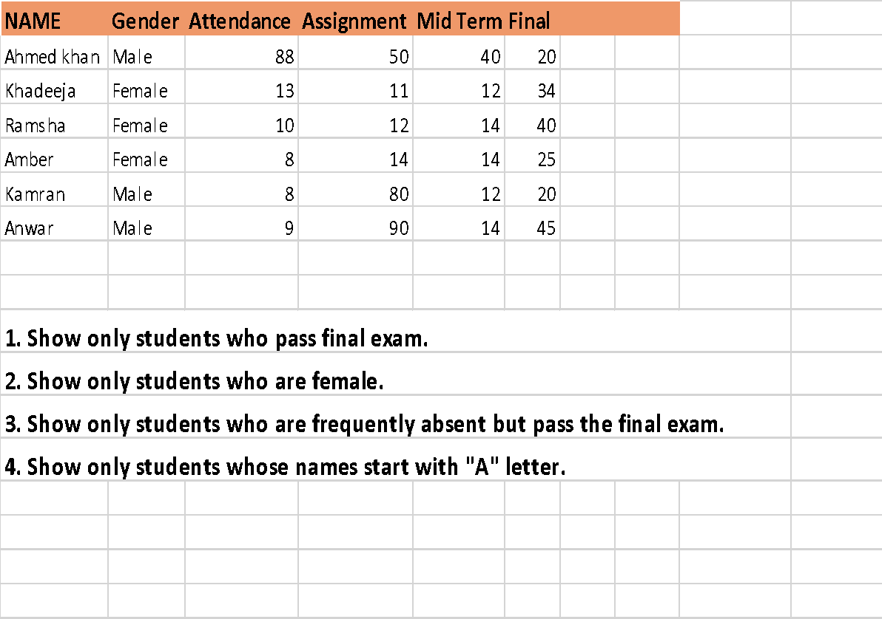

**Question 2:**

Make your own mark sheet containing your Marks Grades and CGPA in first semester using MS excel 2007.

* Must include your name, roll no, semester, year of study, date of declaration of result at top.
* Must include remarks, issued date, verifier’s signature and registrar signature at bottom.
* Must include credit hours for each course, Calculate Quality points and Cumulative grade points average.
* Apply filter, show marks less than 60.
* Apply conditional formatting color scale for marks.

**Question 3:**

By using spreadsheet attached on next page. Perform the indicated operations

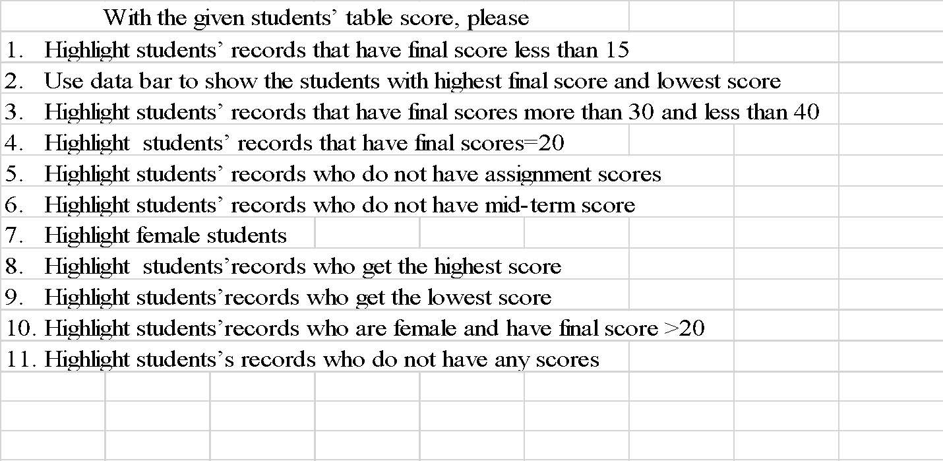

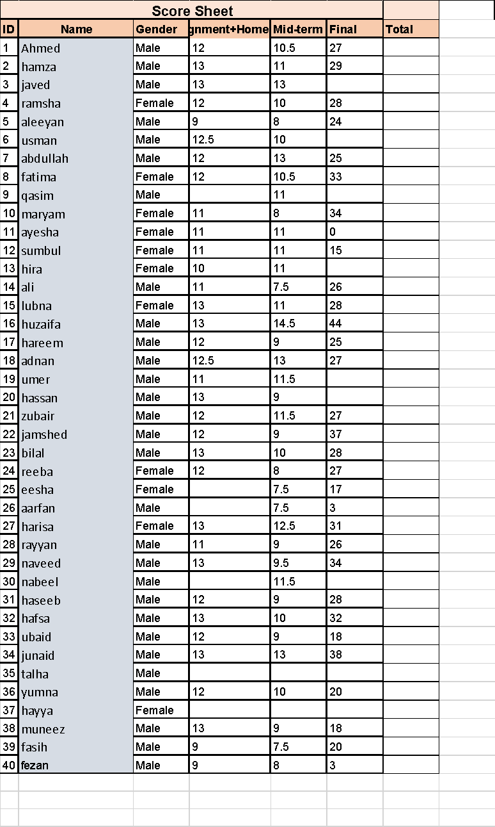

**Question 4:**

Create a frequency distribution table of the following data also sort the data and find mean, median, mode, min, max, range standard deviation and variance using standard formulas and compare the result with built in formulas.

60, 61, 52, 54, 65,97,52,64,70,88,89,65,45,33,21,85,43.98,37,1,7,12,17,28

**Question 5:**

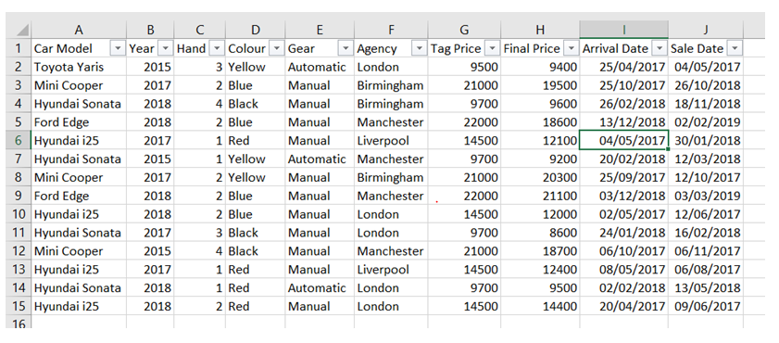

Replicating the Sample Data given above generate 6 different insights that would be great for a statistician/ salesman.

(Hint: Use Pivot Tables and Graphs)